New analogs of 5-substituted-2(1H)-pyridone containing of natural amino acids as potential drugs in idiopathic pulmonary fibrosis. Investigation in silico and preliminary in vitro
Krystyna Dzierzbicka^{1*}, Maria Skrzypkowska², Monika Gensicka-Kowalewska¹, Mateusz Daśko³ and Bartosz Słomiński²
¹Department of Organic Chemistry, Gdansk University of Technology, Gdansk, Poland,
²Department of Medical Immunology, Medical University of Gdansk, Gdansk, Poland,
³Department of Inorganic Chemistry, Gdansk University of Technology, Gdansk, Poland,

Correspondence:
Krystyna Dzierzbicka
krydzier@pg.edu.pl

KEYWORDS: Pirfenidone, PFD, Amino acids, Idiopathic Pulmonary Fibrosis, IPF

Computational studies

Ligands preparation for molecular docking
The 3D structure of ligands 6a-6m (Table 1) were prepared with the Portable HyperChem 8.0.7 Release (Hypercube, Inc., Gainesville, FL, USA). Prior to docking calculations, the structure of each ligand was optimized using a MM+ force field and the Polak–Ribière conjugate gradient algorithm (terminating at a gradient of 0.05 kcal mol⁻¹ Å⁻¹).

Protein preparation for molecular docking
The X-ray structures of the PARPγ, ALK5, and p38 used for molecular modeling studies were taken from the Protein Databank (Protein Data Bank accession codes: 2PRG, 1RW8, and 1KV2, respectively). After standard preparation procedure (including removal of water molecules and other ligands as well as addition hydrogen atoms and Gasteiger charges to each atom) docking analysis was carried out. In the case of PARPγ, the amino acid chains B and C were additionally removed from the structure 2PRG.

Molecular docking
Docking studies were carried out using Autodock Vina 1.1.2 software (The Molecular Graphic Laboratory, The Scripps Research Institute, La Jolla, CA, USA) with exhaustiveness,¹⁶ num modes, and energy range parameters set as 8, 30, and 10, respectively. For the docking studies the corresponding grid box parameters were used:
- PARPγ: a grid box size of 20 Å x 20 Å x 20 Å centered on –OH group of Tyr327 amino acid residue (x = 52.289, y = -30.885, z = 22.176);
- ALK5: a grid box size of 20 Å x 20 Å x 20 Å centered on –OH group of Ser280 amino acid residue (x = 2.407, y = 20.004, z = 9.543);
- p38: a grid box size of 20 Å x 20 Å x 20 Å centered on Cδ of Glu71 amino acid residue (x = 36.026, y = 31.159, z = 13.373).
Graphic visualizations of the 3D model for the poses with the lowest free energies of binding were generated using VMD 1.9 software (University of Illinois at Urbana–Champaign, Urbana, IL, USA).

Table 1. The binding free energy values calculated for potential PARPγ, ALK5, and p38 inhibitors 6a-6m and reference compound PFD.
No. | Structure | Binding free Energy (kcal mol⁻¹)
No. | Structure | PPARγ | ALK5 | p38
PFD |  | -6.6 | -7.7 | -7.4
6a |  | -8.1 | -8.4 | -8.2
6b |  | -8.2 | -8.2 | -8.4
6c |  | -8.3 | -8.7 | -7.9
6d |  | -8.5 | -8.8 | -9.4
6e |  | -8.2 | -8.8 | -9.0
6f |  | -8.9 | -9.6 | -9.8
6g |  | -8.7 | -9.4 | -7.9
6h |  | -8.4 | -9.1 | -8.7
6i |  | -8.6 | -9.0 | -8.4
6j |  | -8.0 | -8.2 | -8.3
6k |  | -9.2 | -9.3 | -9.9
6l |  | -8.0 | -8.6 | -8.8
6m |  | -8.5 | -9.4 | -10.3

ADME can theoretically be calculated using available calculators, e.g. SwissADME (http://www.swissadme.ch/) (Table 2).
Table 2. Selected ADME parameters (H-bond acceptors, lipophilicity, water solubility and pharmacokinetics) of the proposed compounds.
No. | Num. H-bond acceptors
No. | Num. H-bond acceptors | LogPo/w (iLOGP) | LogS (ESOL) | GI absorption
PFD | 1 | 2.34 | -2.73  3.46e-01 mg/ml; 1.87e-03 mol/l | High
6a | 4 | 2.70 | -2.18  1.88e+00 mg/ml;  6.55e-03 mol/l | High
6b | 4 | 2.63 | -2.51  9.29e-01 mg/ml;  3.09e-03 mol/l | High
6c | 4 | 2.92 | -3.19  2.13e-01 mg/ml;  6.48e-04 mol/l | High
6d | 4 | 3.21 | -3.42  1.30e-01 mg/ml;  3.79e-04 mol/l | High
6e | 4 | 3.47 | -3.42  1.30e-01 mg/ml;  3.79e-04 mol/l | High
6f | 4 | 3.15 | -3.92  4.56e-02 mg/ml;  1.21e-04 mol/l | High
6g | 4 | 2.85 | -2.89  4.18e-01 mg/ml;  1.28e-03 mol/l | High
6h | 5 | 1.88 | -2.10  3.08e+00 mg/ml;  7.98e-03 mol/l | High
6i | 5 | 1.80 | -2.70  7.34e-01 mg/ml;  2.00e-03 mol/l | High
6j | 4 | 3.01 | -3.04  3.29e-01 mg/ml;  9.14e-04 mol/l | High
6k | 5 | 3.04 | -3.78  6.52e-02 mg/ml;  1.66e-04 mol/l | High
6l | 5 | 2.20 | -2.21  2.06e+00 mg/ml;  6.23e-03 mol/l | High
6m | 4 | 3.15 | -3.92  4.56e-02 mg/ml;  1.21e-04 mol/l | High

Lipophilicity - LogPo/w(iLOGP); Water solubility - LogS (ESOL); Pharmacokinetics - GI (Gastrointestinal) absorption

Chemical Synthesis
The synthesis of 6-oxo-1-phenyl-1,6-dihydropyridine-3-carboxylic acid 4 was carried out according to the procedure (Zhang and Sommers 2012), and compounds 6b and 6f by the mixed anhydride method (Scheme 1).
Synthesis of methyl-6-oxo-1,6-dihydropyridine-3-carboxylate 2
To a mixture of 4.00 g 6-oxo-1,6-dihydropyridine-3-carboxylic acid (28.75 mmol, 1 eq) 1 in 10 ml anhydrous methanol at 0⁰C was carefully added 2.52 ml SOCl₂ (34,53 mmol, 1.2 eq). After being refluxed for 6 h, the reaction was cooled down to rt and the solvent was evaporated to dryness to give 3 g methyl-6-oxo-1,6-dihydropyridinr-3-carboxylate (19.59 mmol, 68% yield) as a brown powder; melting point 166-172⁰C.
Synthesis of methyl 6-oxo-1-phenyl-1,6-dihydropyridine-3-carboxylate 3
A mixture of 3 g methyl-6-oxo-1,6-dihydropyridinr-3-carboxylate (19.59 mmol, 1 eq), 2.87 g phenylboronic acid (23.53 mmol, 1.2 eq), 5.88 g copper(II) acetate monohydrate (29.41 mmol, 1.5 eq), 3.16 ml pyridine (39.16 mmol, 2 eq) and 3 g molecular sieves (4 Å) in 50 ml dichloromethane were stirred on a magnetic stirrer for 12 hours at ambient temperature. The organic layer was washed with H₂O, dried (MgSO₄), filtered and concentrated under reduced pressure. Further purification by column chromatography (SiO₂; 0.02:1/methanol:chloroform) gave 2.5 g methyl 6-oxo-1-phenyl-1,6-dihydropyridine-3-carboxylate (10.91 mmol, 56% yield) as yellow powder; melting point 100-105⁰C.
Synthesis of 6-oxo-1-phenyl-1,6-dihydropyridine-3-carboxylic acid 4
To a mixture of 1 g methyl 6-oxo-1-phenyl-1,6-dihydropyridine-3-carboxylate (4.37 mmol, 1 eq) in 9 ml THF and 6 ml H₂O at 0⁰C was added 0.37 g LiOHxH₂O (8.74 mmol, 2 eq). After one hour of stirring on a magnetic stirrer, the solution was diluted with water and washed twice with ethyl acetate. Then the water layer was acidified with 2N HCl to pH 2. The white powder obtained was filtered off. 0.74 g of 6-oxo-1-phenyl-1,6-dihydropyridine-3-carboxylic acid (3.44 mmol, 79% yeld) with a melting point of 256-263⁰C was obtained.
Methyl 2-(6-oxo-1-phenyl-1,6-dihydropyridine-3-carboxamido)propanoate 6b
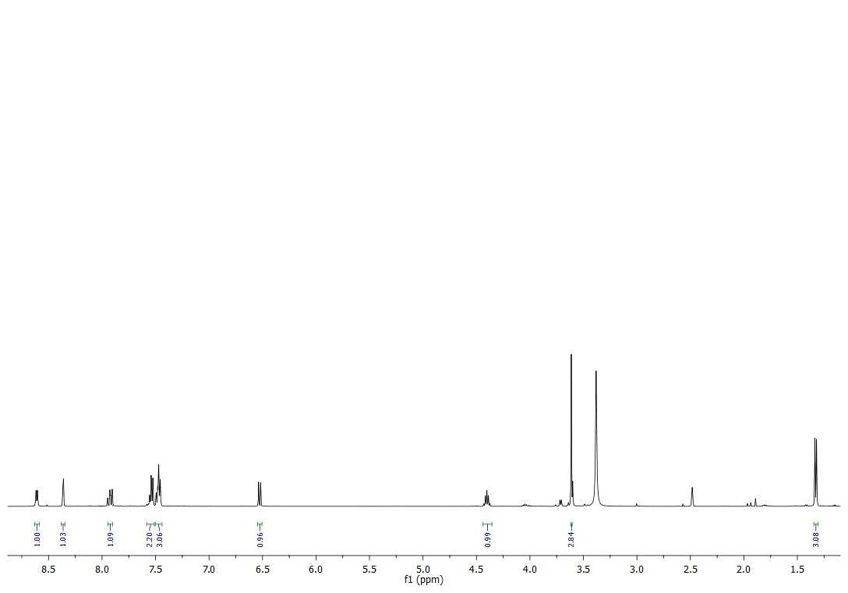

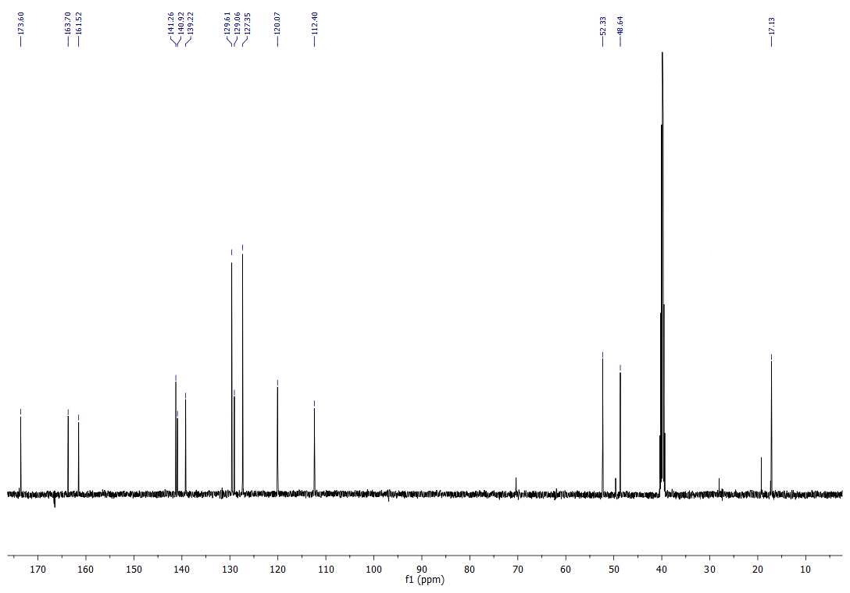

Methyl 2-(6-oxo-1-phenyl-1,6-dihydropyridine-3-carboxamido)-3-phenylpropanoate 6f

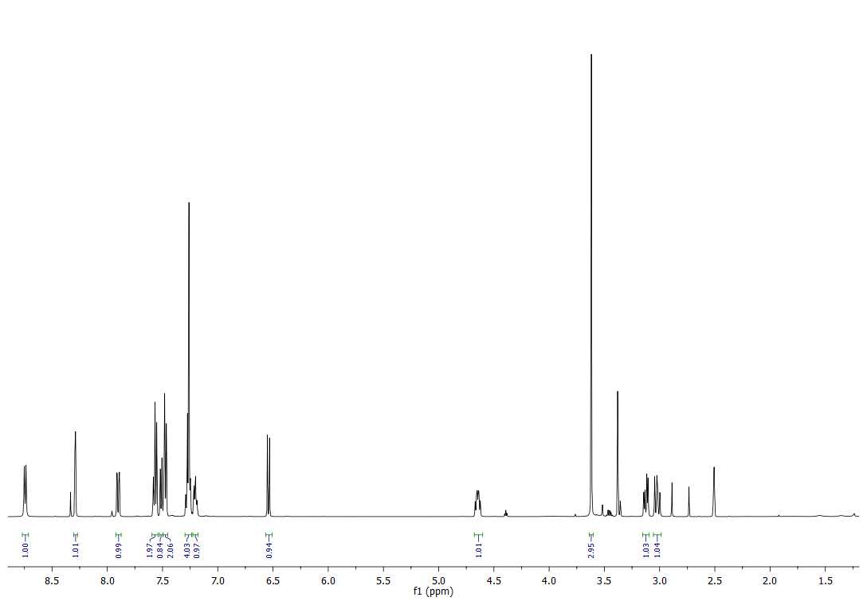

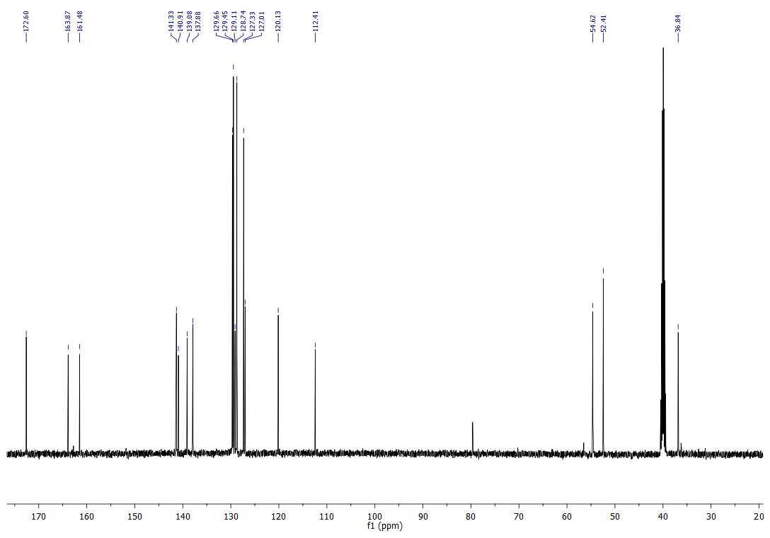
1. Equipment
Chromatographic analysis was performed using Agilent liquid chromatograph series 1290 (Agilent Technology, Waldbronn, Germany) containing: high speed binary pump (G7120A), autosampler (G7167B), thermostated column compartment (G7116B), and diode-array detector (G1315C). The Agilent MassHunter software controlled the chromatographic system.
2. Chromatographic analysis
Samples were dissolved in DMSO and injected (2 µL) onto an RP-C18 silica gel column (Poroshell EC; 2.7 µm, 3.0 × 150 mm, Agilent Technologies) thermostated at 40 °C. The mobile phase flow rate was 0.4 mL min⁻¹, and elution was carried out using 0.1% (v/v) formic acid in water (solvent A) and ACN/MeOH (1:1, v/v) (solvent B). The gradient elution program was as follows: 0 min, 20% B; 0–15 min, linear increase to 100% B; 15–25 min, 100% B. The analysis was stopped after 25 min. The column was re-equilibrated for 15 min at 20% B. The UV signal was monitored at 254, 280, and 350 nm.
Compound 6b
min
2.5
5
7.5
10
12.5
15
17.5
20
22.5
mAU
0
200
400
600
800
1000
1200
1400
6.085
8.206

Purity: 99.93 %
mAU
0
200
400
600
800
1000
1400
1600
UV spectra of compound 6b

minnm
2.5250
5300
7.5350
10400
12.5450
15500
17.5550
20
22.5
mAU
0
250
500
7501200
1000
1250
1500
1750
2000
DAD1 A, Sig=254,8 Ref=off (KN_Phe) Compound 7f
11.787
15.760

Purity: 99.96 %
nm
250
300
350
400
450
500
550
mAU
0
500
1000
1500
2000
UV spectra of compound 6f

Biological Research

Cell cultures

Fibroblasts

In presented study the immortalized human pulmonary fibroblasts purchased from abm (cat. T0490) were used. Cell line was cultured on collaged-coated t25 flasks or 24-well plates in Prirow III medium (abm) supplemented with 1% penicillin/streptomycin solution and 10 % fetal bovine serum at 4x10⁴ cells/cm². Selected cultures media were supplemented with TGF-β1 (1 ng/ml; MERCK) and 6b or 6f analogues for 48h.
Peripheral blood mononuclear cells
Peripheral blood mononuclear cells (PBMCs) were isolated from buffy coats derived from four volunteer donors admitted to Regional Centre for Blood Donation and Treatment in Gdańsk. Cells were isolated using histopaque (Sigma) gradient centrifugation. Isolated PBMCs were cultured on 24-well plates in RPMI 1640 supplemented with 10 % fetal bovine serum at 1x10⁶/ml. Cells were stimulated with anti-CD3/CD28 antibodies-coated beads for 72h and 6b or 6f analogues for 48h.

MTT assay

The viability of fibroblasts cultured in the presence of analogues of 5-substituted-2(1H)-pyridone was evaluated using the MTT test. Analogues were dissolved using DMSO and than diluted in concentrations of 1ng/ml-1mg/ml. 10⁴ fibroblasts per well of 96-well plate were cultured for 24h. After this time media were supplemented with 6b and 6f analogues for additional 48h. Finally, MTT solution was added, followed by 4-h incubation. Obtained formazan crystals were dissolved with DMSO and the absorbance of the resulting solution was measured at 570 nm.

Proliferation test
Trypsin/EDTA (Sigma)-harvested fibroblasts or venous blood-isolated PBMCs were labeled with Violet Proliferation Dye 450 dye (VPD450; BD Biosciences) prior to creating cell cultures. For VPD450 labeling cells were washed twice in PBS and resuspended at up 3x10⁷ cells/ml in pre-warmed PBS with VPD450 at the final concentration of 1 μM. Cells were incubated for 20 minutes (fibroblasts) or 10 minutes (PBMCs) at 37°C. Afterwards cells were washed with PBS and resuspended in appropriate medium with supplements. After 72h cells were harvested and analyzed with the use of flow cytometry. VPD450 can be used to monitor cell divisions as it passively diffuses across cell membranes and is cleaved by esterases in viable cells to create highly fluorescent form. During cell divisions, the VPD450 dye is equally distributed between daughter cells, hence the reduction of fluorescence intensity, measured as Mean Fluorescence Intensity (MFI), with each cell division.
Flow cytometry analyses
Cultured fibroblasts were labelled with monoclonal antibodies (BD Biosciences, USA) specific for HLA-DR (cat. 560652) and CD184/CXCR4 (cat. 555976). For PBMCs 1 µl/ml of GolgySTOP (BD Biosciences) was added into wells 4 hours before culture completion. Intracellular staining for TGF-β (BioLegend, USA; cat. 349610) and IL-17 (BD Biosciences, USA; 560488) was performed with ready-to-use BD Cytofix/Cytoperm Plus (BD Biosciences, USA) kit according to the manufacturer’s suggestions. The expression of cell surface (fibroblasts) and intracellular markers (PBMCs) was assessed using flow cytometry (FACSCantoII, BD Biosciences, USA, USA) after gating on live cells determined by scatter characteristics. Data was analyzed by FACSDiva 6.1.3 software (BD Biosciences, USA).
Scratch test
Scratch test was utilized to measure the migration of pulmonary fibroblasts treated with pyridone analogues. Cells were cultured on 24-well plates in complete PriGrom III medium until they reached ~90 % confluence. The scratch was scraped with the tip of the sterile pipette to create a cell-free zone. Cells were washed twice with warm PBS to remove detached fibroblasts and fresh medium with TGF-β and analogues was added into wells. The scratched area at the same position was monitored and recorded for 24h to analyzed closure rate.
Statistical analysis: Statistical analyses will be performed using Statistica 13 software. ANOVA Friedman and Kruskal-Wallis test will be used for multiple comparisons.

