**Supplementary information**

**Inoculation with *Azotobacter vinelandii* enhanced chlorpyrifos degradation and reduced cytotoxic and genotoxic effects in soil**

Conde Avila Va, Martínez Valenzuela Ca*, Navarro Noya YEb, Bastidas Bastidas PJc

*aLaboratorio de Genotoxicología, Unidad de Investigación en Ambiente y Salud, Universidad Autónoma de Occidente, C.P. 81223, Los Mochis, Sinaloa, México.*

*bCentro de Investigación en Ciencias Biológicas, San Felipe Ixtacuixtla, C.P. 90120, Tlaxcala, México.*

*cCentro de Investigación en Alimentación y Desarrollo, A.C. Unidad Culiacán, Carretera a El dorado km. 5.5, Campo el Diez, 80129 Culiacán, Sinaloa, México.*

*Corresponding author email [camava9@gmail.com](mailto:camava9@gmail.com) cel. number:+52 667 503 0187

**MS/MS acquisition**

Table S1. MS/MS acquisition (gas chromatography)

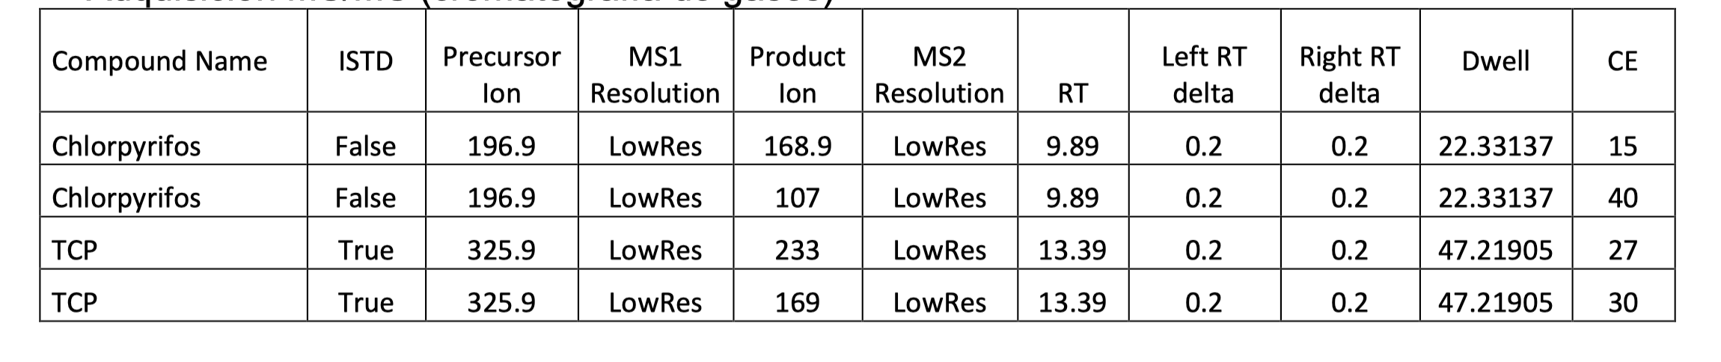

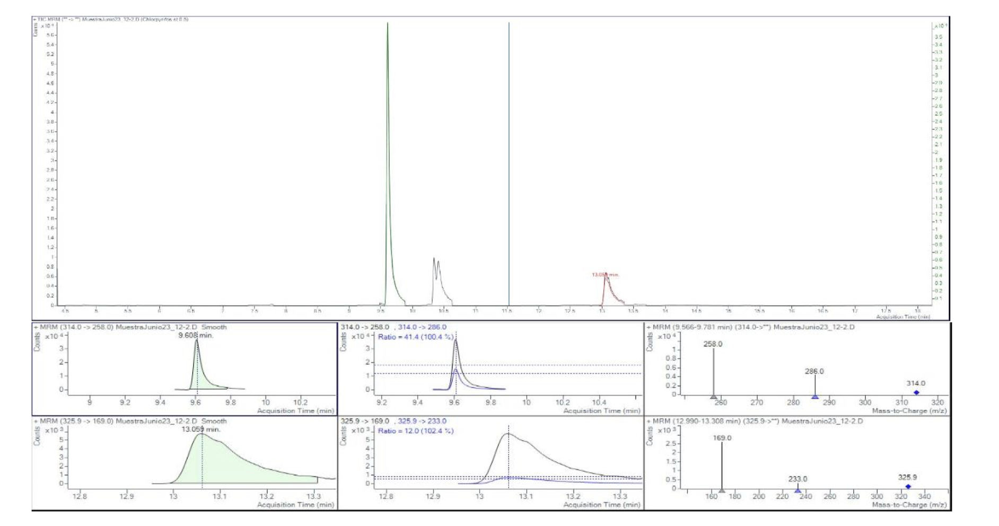

Fig. S1. Chromatogram and ions acquired for chlorpyrifos.

**Identification and quantification**

Identification and quantification were performed by ESI +/- probe on a Waters Xevo TQ-S mass spectrometer and MassLynx workstation. Ions were monitored using MRM (multiple reaction monitoring) for at least two transitions (Figures S2-S4) under the following tandem MS conditions:

Table S2.Tandem MS conditions for chlorpyrifos and its degradation metabolites.

|  |  |  |  |  |  |
| --- | --- | --- | --- | --- | --- |
| Analyte | Parent m/z | Daughter m/z | Dwell (s) | Cone (V) | Collision (eV) |
| Clorpyrifos | 349.8404 | 97.1106  198.1299 | 0.025  0.025 | 2  2 | 30  20 |
| TCP | 196.0000  198.0000 | 196.0000  198.0000 | 0.200  0.200 | 30  30 | 5  5 |
| DETP | 169.000 | 94.8000  141.0000 | 0.085  0.085 | 30  30 | 25  25 |

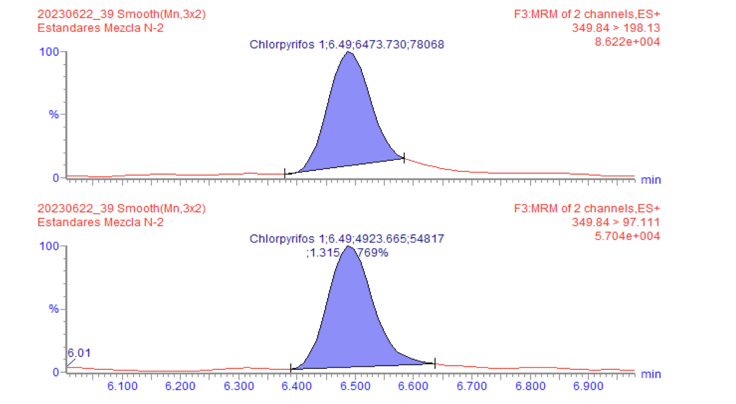

Fig. S2. Transients for chlorpyrifos (5.0 µg/L)

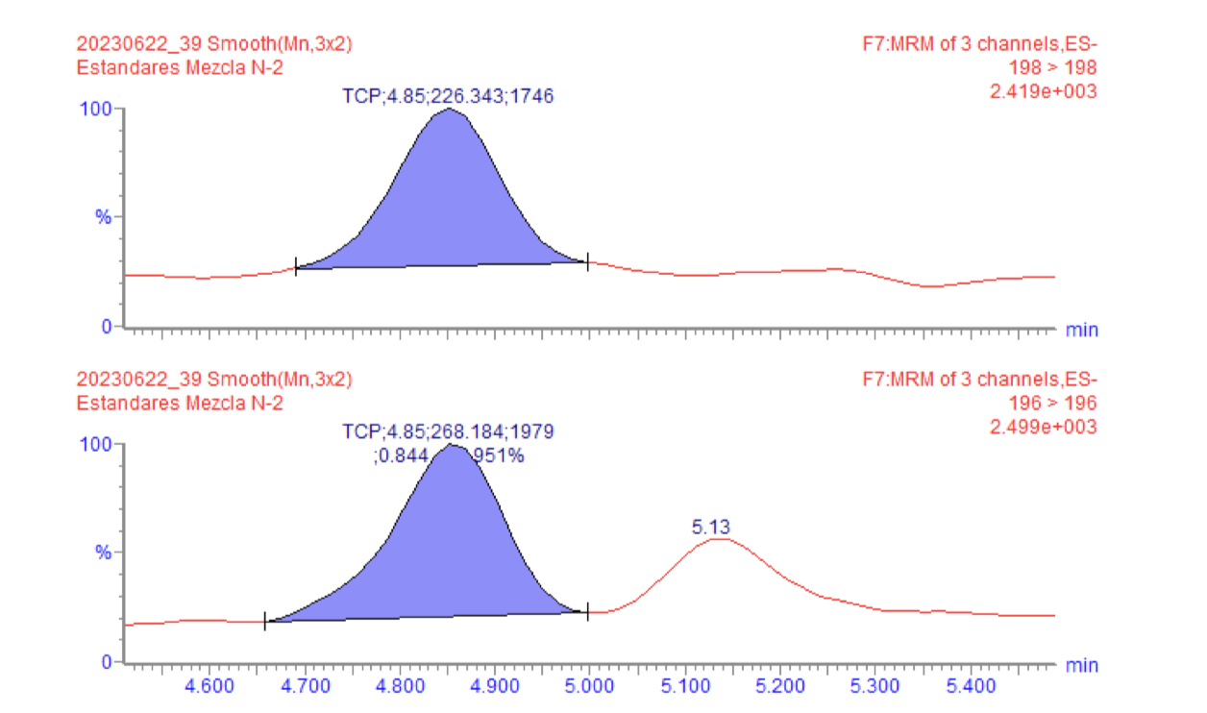

Fig. S3. Transients for TCP (5.0 µg/L)

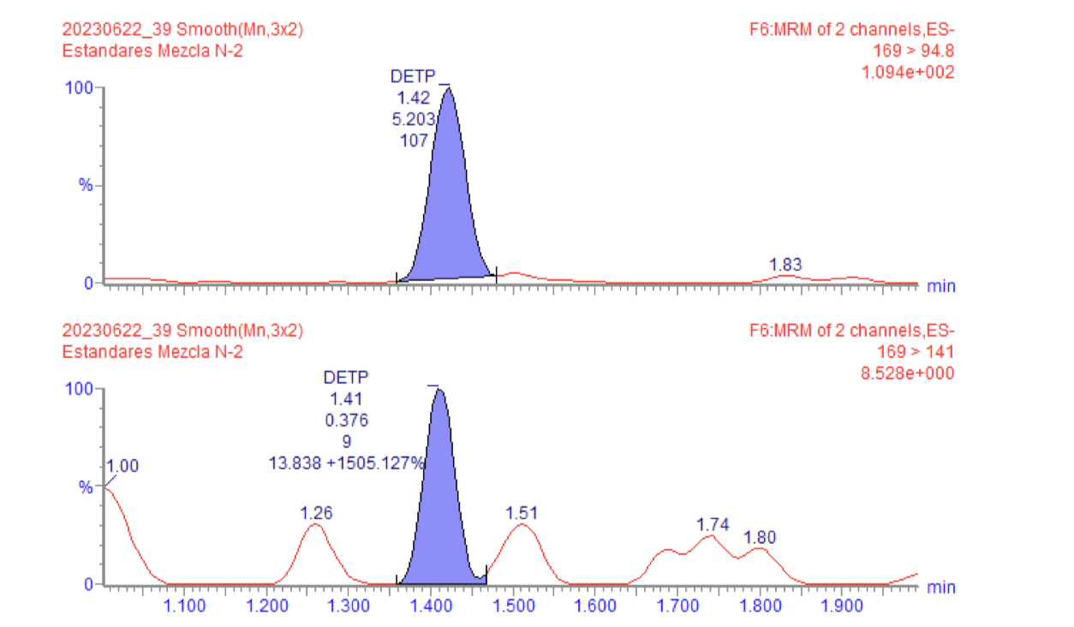

Fig. S4. Transients for DETP (5.0 µg/L)

**Calculations**

Quantification was performed using external standard using the response in area counts.

$$mg{ Kg}^{-1}=\frac{(peak response in the sample)(ng of injected standard) }{(peak response in the standard)(mg sample equivalents injected)}$$

$mg equiv$/ml= $sample weight \left(g\right)*\frac{reconcentrated dispersed extract quota}{volume of extraction solvent}*\frac{1}{final volume}$

**Method performance**

The results of the performance verification of the proposed method for the determination of chlorpyrifos were satisfactory according to the validated method CIAD/PLA-I01-18 (Determination of pesticide residues by gas chromatography) and the AOAC official method for the parameters of linearity, precision under repeatability conditions, trueness (bias), % recovery and limits of detection and quantification.

Table S3. Method performance parameters

|  |  |  |  |  |  |
| --- | --- | --- | --- | --- | --- |
| Pesticide | Linearity *R2* | LD (mg/kg) | LQ (mg/kg) | Accuracy  (Recovery % ) | Precision  (% CV) |
| **Clorpyrifos** | 0.996 | 0.007 | 0.022 | 101.07 ± 5.67 | 5.61 |
| **TCP** | 0.991 | 0.005 | 0.015 | 86.90 | ND |

Table S4. Quality assurance results for chlorpyrifos detection in the soil samples.

|  |  |
| --- | --- |
| MEDIA RECOVERY PERCENTAGE | 103.50 |
| STANDARD DEVIATION | 9.93 |
| % CV | 9.60 |
| CONFIDENCE INTERVAL | 6.309220995 |
| LOWER LIMIT | 97.19 |
| UPPER LIMIT | 109.81 |
| HYPOTHESIS µo | 100.00 |
| t calculated | 0.102 |
| t statistical tables | 2.593 |
| -t (α/2,n-1)<tcalculated<+t (α/2,n-1) | |
| Bias (δ) | 3.500 |
| (t calc = [ Xa –X]/S x √n) tcalculated | 0.102 |
| t tables (t=α/2,n-1) | 2.593 |