**Supplementary material**

**Variations in the functional diversity of root microbiome of Healthy and Northern Corn Leaf Blight Infected Maize (*Zea mays* L.)**

Siphiwe Prudence DLAMINI, Akinlolu Olalekan AKANMU, Olubukola Oluranti BABALOLA*

Food Security and Safety Focus Area, Faculty of Natural and Agriculture Sciences, North-West University, Mmabatho 2735, South Africa

**\*** Corresponding Author: Olubukola.Babalola@nwu.ac.za

Email: Olubukola.babalola@nwu.ac.za

Tel: +27183892568

Fax: +27183892134

**Table S1:** Average percentage of sequences similar to notable metabolisms in soil microbiomes across rhizosphere of healthy and NCLB diseased maize plant

|  |  |  |  |  |  |
| --- | --- | --- | --- | --- | --- |
| **SUBSYSTEMS LEVEL 1** | **LI** | **LID** | **MA** | **MAD** | **Pvalue** |
| **Amino Acid** | 10.57±0.002 | 10.70±0.008 | 10.8±0.06 | 10.76±0.05 | 0.10 |
| **Carbohydrates** | 13.73±0.02 | 14.21±0.002 | 14.99±0.08 | 14.8±0.07 | 0.08 |
| **Cell Division and Cell Cycle** | 0.93±0.00 | 0.93±0.002 | 0.92±0.00 | 0.92±0.003 | 0.42 |
| **Cell Wall and Capsule** | 3.65±0.029 | 3.47±0.03 | 3.30±0.015 | 3.36±0.038 | 0.08 |
| **Clustering-based subsystems** | 12.88±0.04 | 12.97±0.03 | 12.93±0.03 | 12.97±0.03 | 0.28 |
| **Cofactors, Vitamins, Prosthetic Groups, Pigments** | 5.63±0.07 | 5.77±0.005 | 6.05±0.01 | 6.10±0.08 | 0.11 |
| **DNA Metabolism** | 4.60±0.03 | 4.71±0.13 | 4.56±0.03 | 4.56±0.01 | 0.68 |
| **Dormancy and Sporulation** | 0.14±0.003 | 0.16±0.01 | 0.17±0.00 | 0.16±0.00 | 0.20 |
| **Fatty Acids, Lipids, and Isoprenoids** | 2.71±0.02 | 2.72±0.00 | 2.90±0.01 | 2.87±0.01 | 0.14 |
| **Iron acquisition and metabolism** | 0.71±0.02 | 0.66±0.02 | 0.51±0.01 | 0.56±0.01 | 0.08 |
| **Membrane Transport** | 3.86±0.05 | 3.62±0.04 | 3.40±0.03 | 3.42±0.01 | 0.10 |
| **Metabolism of Aromatic Compounds** | 1.87±0.01 | 1.87±0.01 | 2.08±0.00 | 2.02±0.03 | 0.10 |
| **Miscellaneous** | 6.39±0.00 | 6.31±0.09 | 6.31±0.08 | 6.38±0.00 | 0.57 |
| **Motility and Chemotaxis** | 0.98±0.05 | 0.90±0.04 | 0.998±0.00 | 1.01±0.01 | 0.08 |
| **Nitrogen Metabolism** | 1.41±0.02 | 1.44±0.05 | 1.25±0.00 | 1.29±0.03 | 0.11 |
| **Nucleosides and Nucleotides** | 3.31±0.01 | 3.38±0.02 | 3.30±0.01 | 3.31±0.01 | 0.21 |
| **Phages, Prophages, Transposable elements, Plasmids** | 0.82±0.01 | 0.86±0.02 | 0.88±0.01 | 0.87±0.01 | 0.21 |
| **Phosphorus Metabolism** | 1.30±0.00 | 1.29±0.01 | 1.21±0.00 | 1.21±0.01 | 0.15 |
| **Photosynthesis** | 0.10±0.00 | 0.11±0.00 | 0.10±0.00 | 0.10±1.19 | 0.24 |
| **Potassium metabolism** | 0.51±0.01 | 0.47±0.01 | 0.44±0.00 | 0.44±0.01 | 0.10 |
| **Protein Metabolism** | 8.36±0.00 | 8.35±0.05 | 8.17±0.08 | 8.09±0.02 | 0.14 |
| **RNA Metabolism** | 3.46±0.03 | 3.43±0.04 | 3.67±0.01 | 3.28±0.02 | 0.13 |
| **Regulation and Cell signaling** | 0.98±0.01 | 0.96±0.00 | 0.93±0.01 | 0.96±0.01 | 0.11 |
| **Respiration** | 4.24±0.04 | 4.16±0.06 | 4.36±0.01 | 4.28±0.00 | 0.10 |
| **Secondary Metabolism** | 0.30±0.00 | 0.30±0.01 | 0.29±0.00 | 0.31±0.01 | 0.39 |
| **Stress Response** | 2.58±0.03 | 2.63±0.01 | 2.43±0.04 | 2.46±0.02 | 0.10 |
| **Sulfur Metabolism** | 1.01±0.02 | 0.96±0.04 | 0.95±0.01 | 0.95±0.01 | 0.39 |
| **Virulence, Disease and Defense** | 2.95±0.01 | 2.66±0.01 | 2.50±0.04 | 2.56±0.06 | 0.10 |

LI, rhizosphere soil from the healthy maize in Lichtenburg; LID, rhizosphere soil from the diseased maize in Lichtenburg. MA, rhizosphere soil from the healthy maize in Mafikeng, MAD, rhizosphere soil from the diseased maize in Mafikeng.

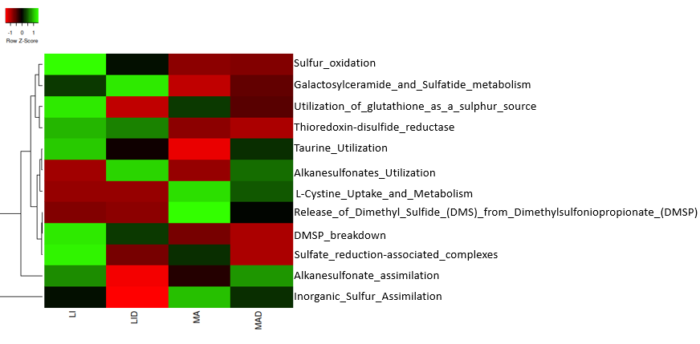

**Figure S1:** Heat map showing the relative abundance of pathways involved in sulfur metabolism in samples across the sites. LI healthy rhizosphere soil, LID diseased rhizosphere soil from the Lichtenburg Farm. MA healthy rhizosphere soil, MAD diseased rhizosphere soil from the University of North West farm.

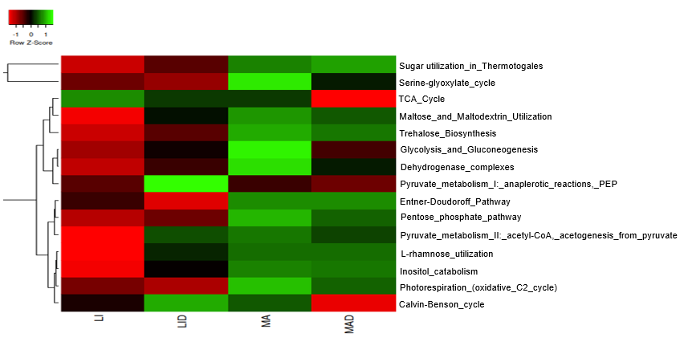

**Figure S2:** Heat map showing the relative abundance of pathways involved in carbohydrates metabolism in samples across the sites. LI healthy rhizosphere soil, LID diseased rhizosphere soil from the Lichtenburg Farm. MA healthy rhizosphere soil, MAD diseased rhizosphere soil from the University of North-West farm.

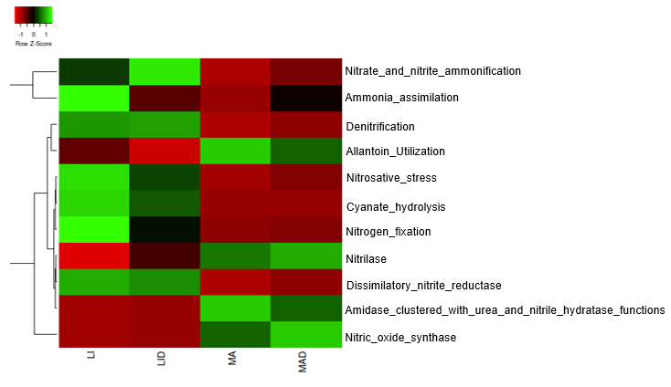

**Figure S3:** Heat map showing the relative abundance of pathways involved in nitrogen metabolism in samples across the sites. LI healthy rhizosphere soil, LID diseased rhizosphere soil from the Lichtenburg Farm. MA healthy rhizosphere soil, MAD diseased rhizosphere soil from the University of North West farm

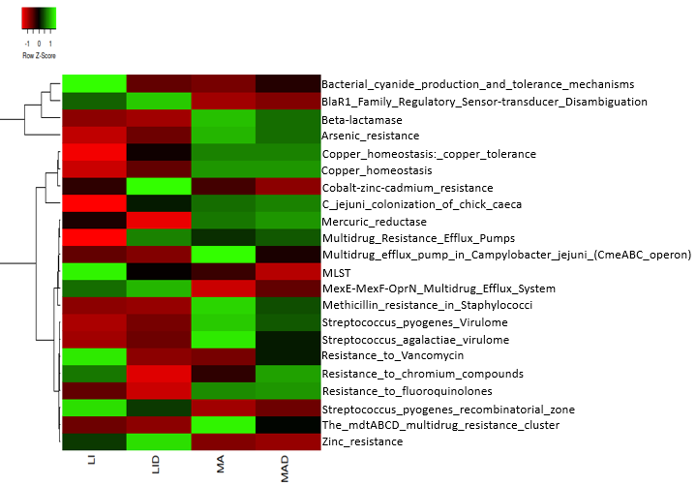

**Figure S4:** Heat map showing the relative abundance of pathways involved in pathways of virulence, disease, and defense of samples across the sites. LI healthy rhizosphere soil, LID diseased rhizosphere soil from the Lichtenburg Farm. MA healthy rhizosphere soil, MAD diseased rhizosphere soil from the University of North-West farm.

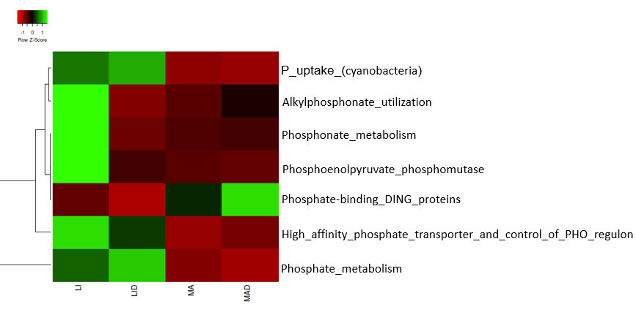

**Figure S5:** Heat map showing the relative abundance of pathways involved in phosphorous metabolism in samples across the sites. LI healthy rhizosphere soil, LID diseased rhizosphere soil from the Lichtenburg Farm. MA healthy rhizosphere soil, MAD diseased rhizosphere soil from the University of North West farm

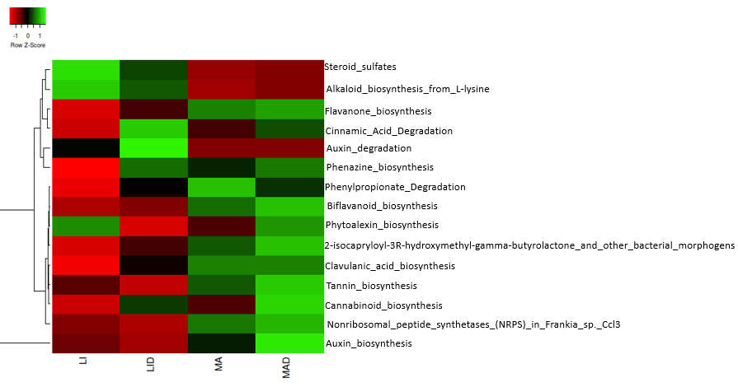

**Figure S6:** Heat map showing the relative abundance of pathways involved in secondary metabolism in samples across the sites. LI healthy rhizosphere soil, LID diseased rhizosphere soil from the Lichtenburg Farm. MA healthy rhizosphere soil, MAD diseased rhizosphere soil from the University of North-West farm

**Table S2:** Relative abundance of sulfur metabolism in the Lichtenburg (healthy and diseased maize plant) and Mafikeng (healthy and diseased maize plant) samples

|  |  |  |  |  |
| --- | --- | --- | --- | --- |
| Metabolic pathway | LI | LID | MA | MAD |
| Alkanesulfonate assimilation | 0.17 | 0.16 | 0.16 | 0.17 |
| Alkanesulfonates utilization | 0.03 | 0.03 | 0.03 | 0.03 |
| DMSP breakdown | 0.0 | 0.0 | 0.0 | 0.0 |
| Galactosylceramide and sulfatide metabolism | 0.11 | 0.11 | 0.10 | 0.10 |
| Inorganic sulfur assimilation | 0.39 | 0.38 | 0.40 | 0.40 |
| L-Cysteine uptake and metabolism | 0.02 | 0.02 | 0.02 | 0.02 |
| Release of Dimethyl Sulfide (DMS) from Dimethylsulfoniopropionate (DMSP) | 0.0 | 0.0 | 0.0 | 0.0 |
| Sulfate reduction associated complexes | 0.0 | 0.0 | 0.0 | 0.0 |
| Sulfur oxidation | 0.12 | 0.09 | 0.08 | 0.08 |
| Taurine Utilization | 0.04 | 0.04 | 0.03 | 0.04 |
| Thioredoxin-disulfide reductase | 0.06 | 0.06 | 0.05 | 0.05 |
| Utilization of glutathione (sulfur source) | 0.07 | 0.06 | 0.07 | 0.07 |

**Table legend:** LI, rhizosphere soil from the healthy maize in Lichtenburg; LID, rhizosphere soil from the diseased maize in Lichtenburg. MA, rhizosphere soil from the healthy maize in Mafikeng, MAD, rhizosphere soil from the diseased maize in Mafikeng.

**Table S3:** Relative abundance of Carbohydrates metabolism in the Lichtenburg (healthy and diseased maize plant) and Mafikeng (healthy and diseased maize plant) samples

|  |  |  |  |  |
| --- | --- | --- | --- | --- |
| Metabolic pathway | LI | LID | MA | MAD |
| Sugar utilization in Thermotogales | 0.82 | 0.86 | 0.69 | 0.67 |
| Serine glyoxylate cycle | 1.27 | 1.26 | 1.33 | 1.30 |
| TCA Cycle | 0.57 | 0.57 | 0.57 | 0.56 |
| Maltose and maltodextrin utilization | 0.52 | 0.58 | 0.61 | 0.60 |
| Trehalose biosynthesis | 0.56 | 0.60 | 0.69 | 0.67 |
| Glycolysis and Gluconeogenesis | 0.45 | 0.46 | 0.48 | 0.46 |
| Dehydrogenase complexes | 0.45 | 0.46 | 0.48 | 0.47 |
| Pyruvate metabolism I: PEP | 0.50 | 0.52 | 0.50 | 0.49 |
| Entner-Doudoroff Pathway | 0.38 | 0.37 | 0.40 | 0.40 |
| Pentose phosphate pathway | 0.36 | 0.37 | 0.43 | 0.42 |
| Pyruvate metabolism II: acetyl-CoA | 0.40 | 0.42 | 0.43 | 0.42 |
| L-rhamnose utilization | 0.30 | 0.33 | 0.34 | 0.34 |
| Inositol catabolism | 0.28 | 0.33 | 0.35 | 0.35 |
| Photorespiration (oxidative C2 cycle) | 0.31 | 0.31 | 0.36 | 0.34 |
| Calvin-Benson cycle | 0.31 | 0.32 | 0.32 | 0.31 |

**Table legend:** LI, rhizosphere soil from the healthy maize in Lichtenburg; LID, rhizosphere soil from the diseased maize in Lichtenburg. MA, rhizosphere soil from the healthy maize in Mafikeng, MAD, rhizosphere soil from the diseased maize in Mafikeng.

**Table S4:** Relative abundance of nitrogen metabolism in the Lichtenburg (healthy and diseased maize plant) and Mafikeng (healthy and diseased maize plant) samples

|  |  |  |  |  |
| --- | --- | --- | --- | --- |
| Metabolic pathway | LI | LID | MA | MAD |
| Nitrate_and_nitrite_ammonification | 0.43 | 0.49 | 0.35 | 0.37 |
| Ammonia_assimilation | 0.56 | 0.55 | 0.55 | 0.56 |
| Denitrification | 0.09 | 0.09 | 0.03 | 0.04 |
| Allantoin_Utilization | 0.07 | 0.07 | 0.08 | 0.08 |
| Nitrosative_stress | 0.02 | 0.02 | 0.01 | 0.01 |
| Cyanate_hydrolysis | 0.02 | 0.02 | 0.01 | 0.01 |
| Nitrogen_fixation | 0.04 | 0.02 | 0.02 | 0.02 |
| Nitrilase | 0.0 | 0.0 | 0.0 | 0.0 |
| Dissimilatory_nitrite_reductase | 0.01 | 0.01 | 0.0 | 0.0 |
| Amidase clustered with urea and nitrile hydratase functions | 0.01 | 0.01 | 0.01 | 0.01 |
| Nitric_oxide_synthase | 0.16 | 0.16 | 0.18 | 0.19 |

**Table legend:** LI, rhizosphere soil from the healthy maize in Lichtenburg; LID, rhizosphere soil from the diseased maize in Lichtenburg. MA, rhizosphere soil from the healthy maize in Mafikeng, MAD, rhizosphere soil from the diseased maize in Mafikeng.

**Table S5:** Relative abundance of virulence, disease, and defense metabolism in the Lichtenburg (healthy and diseased maize plant) and Mafikeng (healthy and diseased maize plant) samples

|  |  |  |  |  |
| --- | --- | --- | --- | --- |
| Metabolic pathway | LI | LID | MA | MAD |
| Bacterial cyanide production and tolerance mechanisms | 0.24 | 0.23 | 0.23 | 0.23 |
| BlaR1 family regulatory sensor-transducer disambiguation | 0.20 | 0.20 | 0.19 | 0.19 |
| Beta-lactamase | 0.22 | 0.22 | 0.31 | 0.29 |
| Arsenic resistance | 0.33 | 0.34 | 0.38 | 0.37 |
| Copper homeostasis: copper tolerance | 0.08 | 0.09 | 0.09 | 0.09 |
| Copper homeostasis | 0.08 | 0.08 | 0.09 | 0.09 |
| Cobalt-zinc-cadmium resistance | 0.09 | 0.10 | 0.09 | 0.09 |
| *Campylobacter jejuni* colonization of chick caeca | 0.12 | 0.14 | 0.15 | 0.15 |
| *Mercuric reductase* | 0.03 | 0.02 | 0.03 | 0.03 |
| Multidrug resistance efflux pumps | 0.02 | 0.03 | 0.03 | 0.03 |
| Multidrug efflux pump in *Campylobacter jejuni* (CmeABC operon) | 0.02 | 0.02 | 0.02 | 0.02 |
| Multilocus sequence typing (MLST) | 0.03 | 0.02 | 0.02 | 0.02 |
| MexE-MexF-OprN multidrug efflux system | 0.02 | 0.02 | 0.02 | 0.02 |
| Methicillin resistance in Staphylococci | 0.02 | 0.02 | 0.03 | 0.03 |
| Streptococcus pyogenes virulome | 0.0 | 0.0 | 0.01 | 0.0 |
| *Streptococcus agalactiae* virulome | 0.0 | 0.0 | 0.0 | 0.0 |
| Resistance to Vancomycin | 0.0 | 0.0 | 0.0 | 0.0 |
| Resistance to chromium compounds | 0.0 | 0.0 | 0.0 | 0.0 |
| Resistance to fluoroquinolones | 0.0 | 0.0 | 0.0 | 0.0 |
| *Streptococcus pyogenes* recombinatorial zone | 0.0 | 0.0 | 0.0 | 0.0 |
| The mdtABCD multidrug resistance cluster | 0.0 | 0.0 | 0.0 | 0.0 |
| Zinc resistance | 0.0 | 0.0 | 0.0 | 0.0 |

**Table legend:** LI, rhizosphere soil from the healthy maize in Lichtenburg; LID, rhizosphere soil from the diseased maize in Lichtenburg. MA, rhizosphere soil from the healthy maize in Mafikeng, MAD, rhizosphere soil from the diseased maize in Mafikeng.

**Table S6:** Relative abundance of phosphorus metabolism in the Lichtenburg (healthy and diseased maize plant) and Mafikeng (healthy and diseased maize plant) samples

|  |  |  |  |  |
| --- | --- | --- | --- | --- |
| Metabolic pathway | LI | LID | MA | MAD |
| P_uptake_(cyanobacteria) | 0.10 | 0.10 | 0.09 | 0.09 |
| Alkylphosphonate_utilization | 0.08 | 0.06 | 0.07 | 0.07 |
| Phosphonate_metabolism | 0.01 | 0.01 | 0.01 | 0.01 |
| Phosphoenolpyruvate_phosphomutase | 0.01 | 0.01 | 0.01 | 0.01 |
| Phosphate-binding_DING_proteins | 0.0 | 0.0 | 0.0 | 0.0 |
| High affinity phosphate transporter and control of PHO regulon | 0.25 | 0.25 | 0.24 | 0.24 |
| Phosphate_metabolism | 0.01 | 0.01 | 0.01 | 0.01 |

**Table legend:** LI, rhizosphere soil from the healthy maize in Lichtenburg; LID, rhizosphere soil from the diseased maize in Lichtenburg. MA, rhizosphere soil from the healthy maize in Mafikeng, MAD, rhizosphere soil from the diseased maize in Mafikeng.

**Table S7:** Relative abundance of secondary metabolism in the Lichtenburg (healthy and diseased maize plant) and Mafikeng (healthy and diseased maize plant) samples

|  |  |  |  |  |
| --- | --- | --- | --- | --- |
| Metabolic pathway | LI | LID | MA | MAD |
| Steroid sulfates | 0.04 | 0.03 | 0.01 | 0.01 |
| Alkaloid biosynthesis from L-lysine | 0.03 | 0.03 | 0.02 | 0.02 |
| Flavanone biosynthesis | 0.02 | 0.02 | 0.02 | 0.02 |
| Cinnamic acid degradation | 0.02 | 0.02 | 0.02 | 0.02 |
| Auxin degradation | 0.03 | 0.03 | 0.03 | 0.03 |
| Phenazine biosynthesis | 0.03 | 0.04 | 0.04 | 0.04 |
| Phenylpropionate_Degradation | 0.0 | 0.0 | 0.0 | 0.0 |
| Biflavanoid_biosynthesis | 0.0 | 0.0 | 0.0 | 0.0 |
| Phytoalexin_biosynthesis | 0.0 | 0.0 | 0.0 | 0.0 |
| 2-isocapryloyl 3R hydroxymethyl-gamma butyrolactone and other bacterial morphogens | 0.0 | 0.0 | 0.01 | 0.01 |
| Clavulanic acid biosynthesis | 0.0 | 0.01 | 0.01 | 0.01 |
| Tannin biosynthesis | 0.01 | 0.0 | 0.01 | 0.01 |
| Cannabinoid biosynthesis | 0.0 | 0.01 | 0.01 | 0.01 |
| Nonribosomal peptide synthetases (NRPS) in Frankia sp. Ccl3 | 0.01 | 0.01 | 0.01 | 0.01 |
| Auxin biosynthesis | 0.10 | 0.10 | 0.10 | 0.10 |

**Table legend:** LI, rhizosphere soil from the healthy maize in Lichtenburg; LID, rhizosphere soil from the diseased maize in Lichtenburg. MA, rhizosphere soil from the healthy maize in Mafikeng, MAD, rhizosphere soil from the diseased maize in Mafikeng.